**CPH Capstone HLR v0.3.1**

**Author: Josh Trimm**

**Edited by Joshua Trimm and Phil Pfeiffer**

**Last Updated 12 September 2021**

Contents

1 Summary 2

2 Stakeholders 2

2.1 External 2

2.2 Internal 2

3 Definitions 2

3.1 Users 2

3.1 External Dependencies 2

3.2 Data Model 3

3.3 Development 3

4 System Architecture 3

4.1 Authentication 3

4.2 Permissions 3

4.3 Region Management 3

4.4 CSV Management 3

5 Out of Scope 4

5.1 Security 4

5.2 Content 4

5.3 Internal Architecture 4

5.4 Responsiveness to changes in stored data 4

5.1 User Interface Quality 4

5.2 Data Analysis and Visualization 4

5.3 Implementation 4

6 Front-end Development 5

6.1 Search and Filtering 5

6.1.1 Chart Creation & Editing 5

6.2 Design 5

6.3 Sitemap 5

6.4 Dashboard 6

7 Non-Functional Requirements 6

7.1 External 6

7.1.1 Integrity 6

7.1.2 Usability 6

7.1.3 Installability 6

7.2 Internal 6

7.2.1 Modifiability 7

7.2.2 Reusability 7

7.2.3 Verifiability 7

8 Feature Tree 8

8.1 Features 8

# Summary

Dr. Randy Wykoff and Ms. Dara Young have asked the ETSU Department of Computing to develop a web-based system that displays percentile charts, generated from data points associated with groups of U.S. counties. This data is to be downloaded from a web repository maintained by Community Health Resources ([www.chrhealth.org](http://www.chrhealth.org)) and stored in a database, by year, county, and health indicator. The groups of counties for which the charts shall be generated, which the clients refer to as *regions*, are to be specified by the clients and stored in the system’s database.

This system will need a web interface, to enable interaction with the system; a permissions module; a CSV uploading module for inputting the CHR data; a chart module; a module for creating regions; and a process for deploying the completed site. Completing this work should create a basis, given a modular architecture, for further development by subsequent capstone participants.

# Stakeholders

## External

|  |  |  |  |
| --- | --- | --- | --- |
| Person | Role | Email | Link |
| Dara Young | Health Services Coordinator | [youngdc@etsu.edu](mailto:youngdc@etsu.edu?Subject=) | <https://www.etsu.edu/cph/faculty/youngdc.php> |
| Dr. Randy Wykoff | Dean | [wykoff@etsu.edu](https://www.etsu.edu/SPECIAL_LINKsomeoneAT_ETSU?Subject=) | <https://www.etsu.edu/cph/faculty/wykoff.php> |

## Internal

|  |  |  |  |
| --- | --- | --- | --- |
| Person | Role | Email | Link |
| Dr. Phil Pfeiffer | Capstone Advisor | [phil@etsu.edu](mailto:phil@etsu.edu) | <https://www.etsu.edu/cbat/computing/faculty_and_staff/> |
| Joshua Trimm | Student Capstone Participant | [trimmj@etsu.edu](mailto:trimmj@etsu.edu) |  |

# Definitions

## Users

* **CPH Admin a.k.a Admin**: an individual with full permissions control. This user can add/remove cartographers, add/edit/remove regions, add/edit/remove charts, and add/remove uploaded CSV files.
* **Cartographers**: users who have been registered by an Admin. Each cartographer can create charts and regions and edit and remove those charts and regions that (s)he has created. Cartographers can also upload the new CSV files as they become available: typically, once per year.
* **Browser**: users who navigate to the website to browse the charts created by an Admin or the Cartographers.
* **Chart Creators:** Admins and Cartographers
* **Region Creators**: Admins and Cartographers

## External Dependencies

* **County Health Rankings (CHR) website.**  County Health Rankings is: a program sponsored by [University of Wisconsin Population Health Institute](https://uwphi.pophealth.wisc.edu/). It tracks U.S. health data on a per-county basis, making this data available annually through its website, <https://www.countyhealthrankings.org/>, as a CSV file[1].

## Data Model

* **Health Indicator:** a set of time-stamped data points downloaded from the CHR website. Each indicator is stored in its own column, headed by a string that names the indicator.
* **Region**: a user-defined collection of two or more US counties.

## Development

* **AWS**: Amazon Web Services
* **D3**: a non-proprietary, standards-based JavaScript library for manipulating documents based on data. D3 supports the use of HTML, SVG, and CSS to create web pages and charts. D3 combines powerful visualization components with a data-driven approach to DOM manipulation (*d3js.org*).
* **Twitter Bootstrap**: A library for making websites fluid or responsive.
* **ASP.Net**: Microsoft’s C# library for web app development.
* **Subsystems**: loosely defined as features.
* **Features**: consists of one or more logically related system capabilities that provide value to a user and are described by a set of functional requirements (Wiegers & Beatty, 2013).

# System Architecture

The intended system will be structured as a set of three interacting subsystems that depend on ASP.NET core mechanisms for authenticating users and validating their use of the system’s functions.

## Authentication

ASP.NET core’s authentication APIs support the use of browser-file-based cookies to track users. It allows developers to specify when these cookies expire and removes cookies automatically when users log out.

## Permissions

ASP.NET core’s permissions APIs allow developers to define roles for system users and to associate roles with permissions for system usage. Based on who is logged in – or not – the website will show different functionality.

Chart ManagementThe Chart Management subsystem supports the creation, display, and editing of percentile charts. The second version of the Chart Management system should extend this support to other types of charts.

## Region Management

The Region Management subsystem allows Admins and Cartographers to define custom regions. Regions will be saved with the date they are created and who created them. Each user who creates a region shall be able to modify that region’s makeup by adding counties to or removing counties from that region. This action of redefining a region, however, shall not affect any charts that have been created and stored for earlier versions of that region.

## CSV Management

This system will support a function that backend users of the CPH system can use to retrieve the CHR’s data for the current year. This function, when invoked, will, for now, upload the file(s) that contain this data to a local directory, which will act as a repository for all CHR data. The function will assign these file(s) a name, based on the data’s associated year. Finally, this function will record when the document was uploaded and who uploaded it in the CPH database.

# Out of Scope

## Security

* **Two Factor Authentication (F2A) –** Microsoft offers an authentication service allowing users to setup F2A. Ideally, the F2A will be integrated into ETSU’s Microsoft Identity Platform to ensure that all users are members of ETSU.

## Content

* **Additional data sources** – currently the system is only designed to handle CSVs from the CHR. Other CSV’s will break the system and should not be used.

## Internal Architecture

* **Saving CSV to an external file system (industry best practice)** – For now, all uploaded CSV’s will be stored locally. This is not industry best practice and should be addressed in a future iteration. Files being uploaded to the host’s directory could have malicious scripts and crash the system.
* **Logging** – Support for logging should be added to the system at some point, in order to track its use, including potential anomalies in its operation. ASP.NET core logging APIs could (and should) be used to support logging.

## Responsiveness to changes in stored data

* **Deletion of a Cartographer** – Deleting a cartographer can cause chart failures. Extra functionality will be needed to ensure that any charts that are owned by a deleted cartographer are either deleted or transferred to another user. Client input will be needed as to how this transfer should be effected.
* **Deletion of a Region** – Deleting a region that has been used to produce charts could cause multiple chart failures. For future development, the client needs to be consulted as to how to manage charts that depend on a deleted region.
* **Updating of a Region** – Similarly, the ability to change the counties that are included in a region that has been used to produce charts will not be supported by this system.
* **Deletion of a CSV file** – While it is assumed that CSV files, once downloaded, will not be deleted, this assumption needs to be confirmed with the client.
* **Updating of a CSV file** – The updating of stored charts with data culled from an updated CSV file—one (e.g.) that CHR has revised as a way of correcting bad data—shall not be supported by this system.

## User Interface Quality

* **Beautification of UI** – Having a beautiful website that is UX optimized constitutes a project within itself. For the scope of this capstone, a usable responsive UI will be developed.
* **Map –** Currently the CPH had no interest in having a map displayed for users to select counties. This might be a feature that the clients would consider in the future.
* **Accessibility** – Further work will be needed to assure the site’s eventual compliance with ADA requirements.

## Data Analysis and Visualization

* **Additional charts** – Currently, the percentile chart is the only chart in development. The chart module will be developed in a way that will enable the ready addition of other types of charts and chart-related features.
* **Advanced Filtering –** Additional search features for Regions, Health Indicators, Creator, or Year will need to be added in future iteration of the capstone. For this iteration, users will have one basic search functionality for each feature. *These are defined in the* ***Front-end Development*** *section.*

## Implementation

* **Deployment** – While instructions for deploying the system will be provided as part of this work, the actual work of deployment will be left to ETSU staff and faculty.

# Front-end Development

The system’s web-based front-end will support standard features for interacting with web-based systems. Its navigation systems will provide access to its contents and features. Different navigation systems will be provided for different types of browsing.

## Search and Filtering

### Chart Creation & Editing

The chart creation and editing page will provide fields that enable users to create charts based on CSV year, region, counties of special interest, and choice of health indicators.

## Design

The website’s initial design will be quite basic, due to a lack of developer resources and a need to focus on implementing essential functionality. Basic usability features to view the website on all devices will be implemented using Twitter’s CSS-based Bootstrap library. Custom color schemes, layouts, and flashy displays are currently out of scope, as is support for users with impaired sight and other disabilities.

## Sitemap

* Back-end view (Dashboard) – only for Admins and Cartographers
  + Home
    - Displays a user’s name and navigational icons for creating a region, creating a chart, browsing the charts that they have created, and browsing the regions they have created
  + Create Region
    - Allows Admins and Cartographer to create regions from a database-provided list of U.S. counties
  + Create Chart
    - Allows Admins and Cartographers to create a percentile chart to compare a region or county against the US, relative to a single type of data
  + Account
    - Displays the user's name and contact information and enables the editing of this information
  + Edit Region
    - Allows Cartographers to edit a region they have defined
    - Allows Admins to edit/remove any region
  + Edit Chart
    - Allows Cartographers to edit a chart they have defined
    - Allows Admins to edit/remove any chart
  + CSV Upload
    - Allows Admins and Cartographers to upload the yearly CSV data points from the CHR website
  + CSV Browser
    - Displays the name of each uploaded CSV file, its upload date, and who uploaded that file.
* Front-end view
  + Home
    - Provides an overall description of the site and its functions
  + About
    - Provides a more in-depth description of what the site does and the CPH
  + Contact
    - Displays the CPH’s contact information
  + Chart Browser
    - Displays all publicly available charts with a brief description of each chart.
  + Chart View
    - Displays a single chart's total information: i.e., the region name, the counties it contains, the chart’s data point, the creator’s username, the date of creation, the title, and the creator’s contact info.

## Dashboard

The dashboard is where Admins and Cartographers will manage charts, regions, personal contact information, and CSV’s. It will consist of eight pages, as described in the Sitemap Back-end sections. Users with Admin and Cartographer permissions will be required to log in to the system to view the dashboard. No other users will have access to the dashboard.

# Non-Functional Requirements

Tables one and two below show the most relevant quality attributes for the CPH website project. Higher scores represent a quality attribute's significance. For this project, the three that scored the highest, for external and internal, will be the attributes of major concern.

*Please view the* ***Quality Attributes Scenario’s*** *document for more information.*

## External

Table Most relivant external quality attributes

|  |  |  |  |  |  |  |  |
| --- | --- | --- | --- | --- | --- | --- | --- |
| Attribute | Score | Availability | Installability | Integrity | Performance | Security | Usability |
| Availability | 2 |  | ^ | ^ | < | < | ^ |
| Installability | 3 |  |  | ^ | < | < | ^ |
| Integrity | 5 |  |  |  | < | < | < |
| Performance | 1 |  |  |  |  | < | ^ |
| Security | 0 |  |  |  |  |  | ^ |
| Usability | 4 |  |  |  |  |  |  |

### Integrity

* **Definition**: The extent to which the system protects against data inaccuracy and loss (Wiegers & Beatty, 2013).

### Usability

* **Definition**: How easy it is for people to learn, remember, and use the system.

### Installability

* **Definition**: How easy it is to correctly install, uninstall, and reinstall the application.

## Internal

Table Most relevant internal quality attributes

|  |  |  |  |  |  |  |  |
| --- | --- | --- | --- | --- | --- | --- | --- |
| Attribute | Score | Efficiency | Modifiability | Portability | Reusability | Scalability | Verifiability |
| Efficiency | 0 |  | ^ | ^ | ^ | ^ | ^ |
| Modifiability | 5 |  |  | < | < | < | < |
| Portability | 1 |  |  |  | ^ | ^ | ^ |
| Reusability | 4 |  |  |  |  | < | < |
| Scalability | 2 |  |  |  |  |  | ^ |
| Verifiability | 3 |  |  |  |  |  |  |

### Modifiability

* **Definition**: How easy it is to maintain, change, enhance, and restructure the system

### Reusability

* **Definition**: To what extent components can be used in other systems

### Verifiability

* **Definition**: How readily developers and testers can confirm that the software was implemented correctly.

# Feature Tree

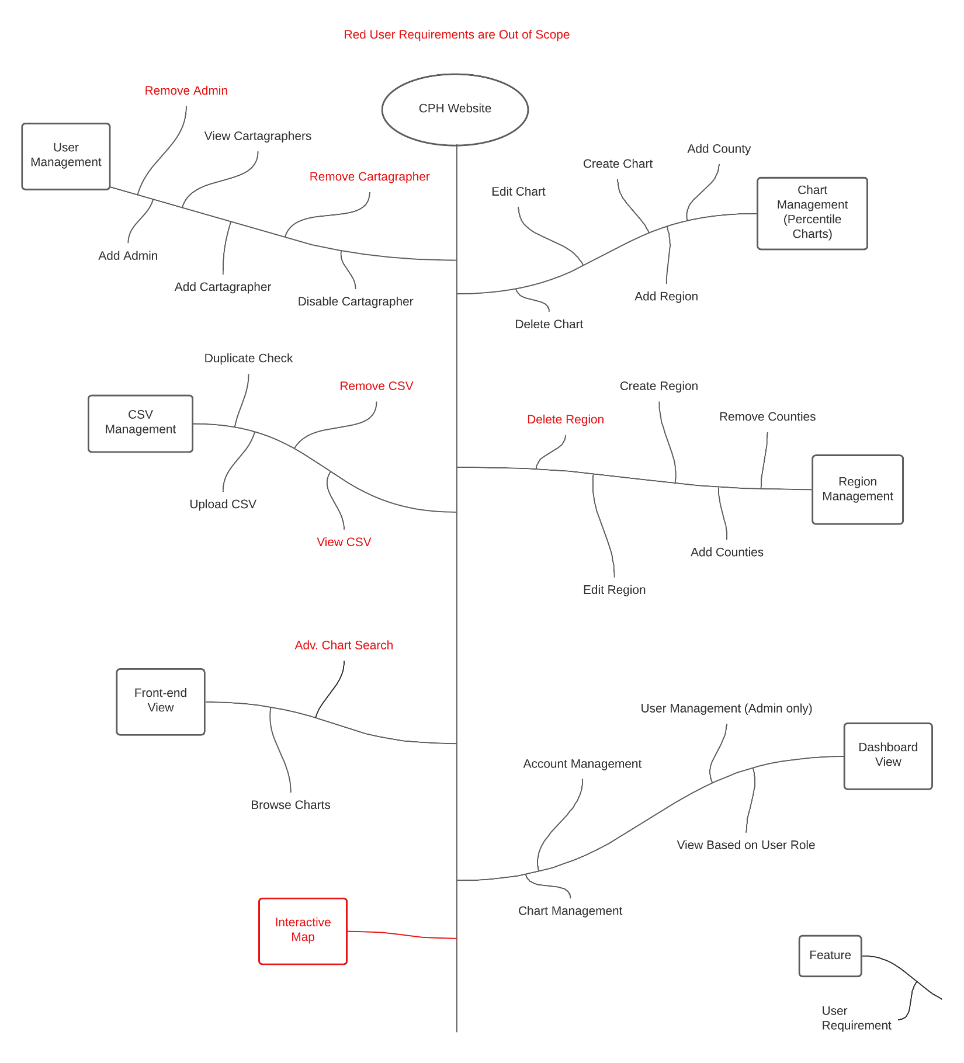

## Features

The features listed in the tree above are elaborated on in separate functional requirements files.

* Interactive Map
* Dashboard View
* Front-end View
* Region Management
* Chart Management
* CSV Management
* User Management

1. These files can be found at this address: <https://www.countyhealthrankings.org/explore-health-rankings/rankings-data-documentation>